"Knocking on heavens Door" by Bob Dylan.  -----------------------------------------  ---------Vers 1------------------------  G D Am  Mama, take this badge off of me  G D Am  I can't use it anymore.  G D Am  It's gettin' dark, too dark to see  G D Am  I feel I'm knockin' on heaven's door.  ---------chorus------------------------  G D Am  Knock, knock, knockin' on heaven's door  G D Am  Knock, knock, knockin' on heaven's door  G D Am  Knock, knock, knockin' on heaven's door  G D C  Knock, knock, knockin' on heaven's door  ---------Vers 2-------------------------  G D Am  Mama, put my guns in the ground  G D Am  I can't shoot them anymore.  G D Am  That long black cloud is comin' down  G D Am  Feels like I'm knockin' on heaven's door.  ---------Chorus-------------------------  G D Am  Knock, knock, knockin' on heaven's door  G D Am  Knock, knock, knockin' on heaven's door  G D Am  Knock, knock, knockin' on heaven's door  G D C  Knock, knock, knockin' on heaven's door | G dur  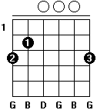  D dur  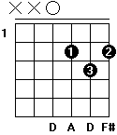  A m  