Give My Love to Rose Johnny Cash

INTRO:
e----------------------------------------------------------------------|
B----------------------------------------------------------------------|
G----------------------------------------------------------------------|
D----------------------------------------------------------------------|
a--0--2--3--4--4--4--3--2--0-------------------------------------------|
e----------------------------------------------------------------------|

A E A
I found him by the railroad track this morning
A E A
I could see that he was nearly dead
D A
I knelt down beside him and I listened
B7 E
Just to hear the words the dying fellow said

A E A
He said they let me out of prison out in Frisco
A E A
For ten long years I've paid for what I've done
D A
I was trying to get back to Louisiana
E A
To see my Rose and get to know my son

Chorus:
D A
Give my love to Rose please won't you mister
E A
Take her all my money, tell her.. buy some pretty clothes
D A
Tell my boy that daddy's so proud of him
E A
And don't forget to give my love to Rose

INTRO

A E A
Wouldn't you tell them I said thanks for waiting for me
A E A
Tell my boy to help his mom at home
D A
Tell my Rose to try to find another
B7 E
Cause it ain't right that she should live alone

A E A
Mister here's a bag with all my money
A E A
It won't last them long the way it goes
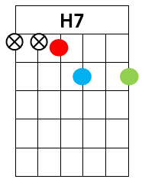
D A
God bless you for finding me this morning
E A
Now don't forget to give my love to Rose

Chorus

