I Still Can´t Say Goodbye Chet Atkins
Capo II

G C D - G C D
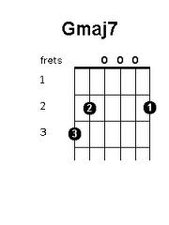
G D C D G D Hm C
When I was young, my Dad would say Come on Son let's go out and play
G D C Dsus4 D - Em D G - C D
Sometimes it seems like yesterday

G D C D G D Hm C
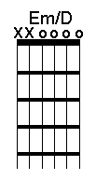
And I'd climb up the closet shelf When I was all by my-self
G D C Dsus4 D - Em D G
Grab his hat and fixed the brim Pretending I was him

D C G
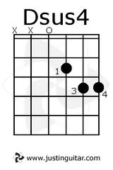
No matter how hard I try
D C G
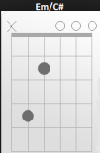
No matter how many tears I cry
D Em D Em/C#
No matter how many years go by
C D C Em D - G Em D
I still can't say good-bye

G D C D G D Hm C
He always took care of Mom and me. We all cut down a Christmas tree
G D C Dsus4 D - Em D G
He always had some time for me

C D Em Em/D
Wind blows through the trees
C D Gmaj7
Street lights, they still shine bright
C D Em Em/D
Most things are the same
Em/C# C Dsus4 D
but I miss my Dad to-night

G D C D G D Hm C
I walked by a Salvation Army store Saw a hat like my daddy wore
G D C Dsus4 D - Em D G
Tried it on when I walked in Still trying to be like him

D C G
No matter how hard I try
D C G
No matter how many years go by
D Em D Em/C#
No matter how many tears I cry
C D C Em D - G Em D - G
I still can't say good-bye

